**SAP Routes & Layers: Step by Step Configuration**

**Consolidation routes** – We need to establish a consolidation route for each transport layer. Development/ Integration system is taken as the source of these consolidation routes. Quality assurance/ Consolidation system as the transport target. Any modified objects that have a consolidation route for their transport layer can be included in change/transport requests. After the request has been released the objects can be imported into the consolidation system. If the changes are made to the objects with no consolidation route set-up (or in Customizing requests without a transport target) for their transport layer, such changes will be automatically taken as local change requests, i.e., not-transportable. **Only one consolidation route per transport layer per system can be set-up**.

[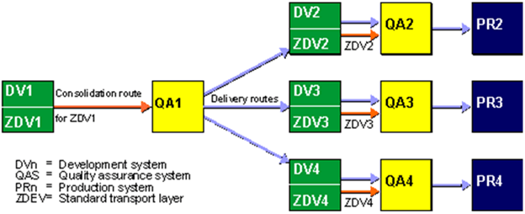](https://www.guru99.com/images/sap/2013/05/050813_0640_TransportMa11.png)

**Setting up Transport Routes**

Once the Domain and other systems of a landscape are defined, we need to connect them with the help of proper transport routes (and layers). As for many customers' systems landscape fall into the same categories, the TMS provides some standard system groups that can be used for easily defining routes. When standard options are used, routes are generated automatically; we can select one of the following options:

* Single System
* Two-System landscape: DEV and PRD
* Three System landscape: DEV, QAS, and PRD

If we need to define a more complex transport system, we can also use standard options initially and there after defining additional consolidation and delivery routes.

**Transport Routes – Standard Configuration**

[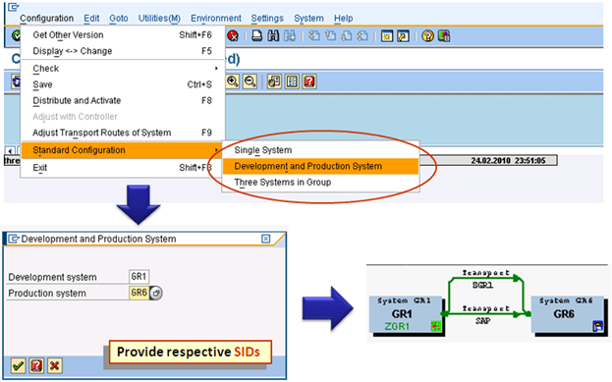](https://www.guru99.com/images/sap/2013/05/050813_0640_TransportMa12.png)

**Transport Routes – Manual Configuration**

[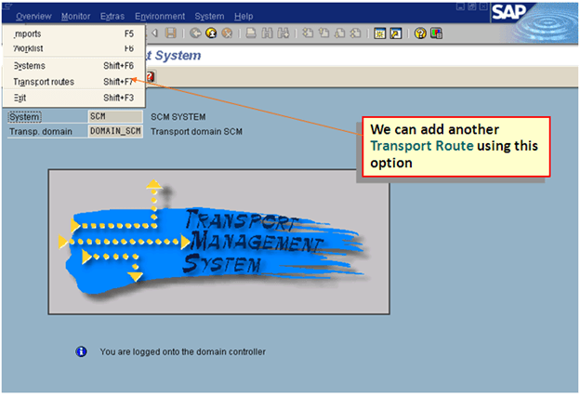](https://www.guru99.com/images/sap/2013/05/050813_0640_TransportMa13.png)   
  
[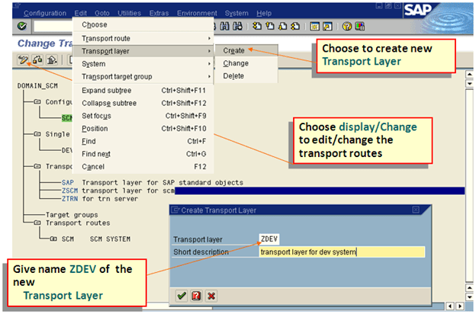](https://www.guru99.com/images/sap/2013/05/050813_0640_TransportMa14.png)  
  
[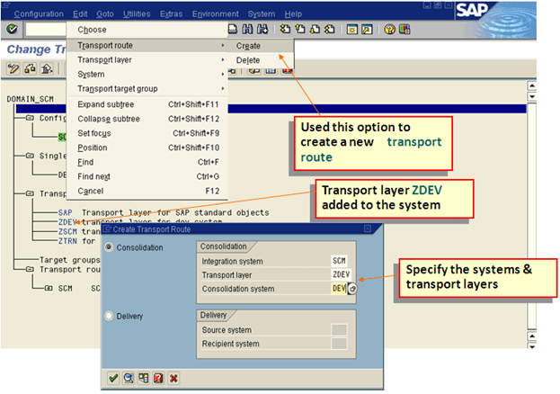](https://www.guru99.com/images/sap/2013/05/050813_0640_TransportMa15.png)  
  
[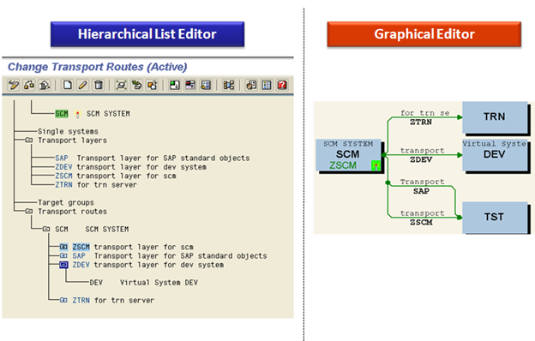](https://www.guru99.com/images/sap/2013/05/050813_0640_TransportMa16.png)

**Transport Routes**

[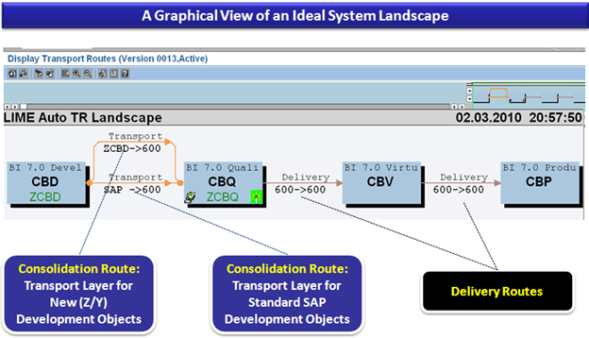](https://www.guru99.com/images/sap/2013/05/050813_0640_TransportMa17.png)

**Distributing and Verifying the Configuration**

* After the transport route settings are made or modified in the domain controller, all other member systems of the domain ought to know the new configuration. For that we need to execute **STMS -> Transport Routes Screen -> Systems Overview -> Configuration -> Distribution and Activate Configuration**
* Additionally, we should also verify various check-points, to ensure that the whole arrangement is behaving in the desired manner:
  + For **RFC Connections:** Overview -> Systems -> SAP System ->Check -> Connection Test
  + For **Network**: Transport Routes Overview -> Config. -> Check -> Request Consistency
  + For ***tp*& TPPARAM**: System Overview Screen -> SAP System -> Check -> Transport Tool